**Sri Lanka Institute of Advanced Technological Education Higher National Diploma in Information Technology**

**Higher National Diploma in Information Technology**



**Database Document**

**“LS Transport”**

(Desktop Application for Cab Service)

|  |  |  |
| --- | --- | --- |
| Name Of the student | Register Number | Signature |
| H.A.L.E.S.Gunasekara | ANU/IT/2019/F/0055 |  |

(HNDIT2404)

Project(individual)

Supervisor: Mr. Pavaridu sahansith

Academic Year: 2019/2021 Year 2-Semester 02(Fulltime)

Submission Date: (10/11/2021)

Table of content

1. Introduction……………………………………………………………………
2. ER diagram……………………………………………………………………
3. ER to relational mapping………………………………………………………
4. Normalization…………………………………………………………………..
   1. UN formation……………………………………………………………..
   2. 1st normalization…………………………………………………………..
   3. 2nd normalization………………………………………………………….
   4. 3rd normalization………………………………………………………….
5. **Introduction**

The database document is submitted to meet software development requirements of the individual project module conduct by the Sri Lanka Institute of Advanced Technological Education (SLIATE).

The purpose of the Database Design Document that maps the logical data model to the target database management system with consideration to the system’s performance requirement. The database design converts logical or conceptual data construct to physical storage construct of the target database management system. This document describes the database of our project.

It is described under the following headings,

ER diagram

ER to relational mapping

Normalization

ER diagram used to analyze existing database to find and resolve problems in logic or deployment. And show the relationship among tables and their attributes. ER diagram shows the complete logical structure of database.as well as relation mapping, we can clearly display the relationship between its members. Normalization can reduce data redundancy & eliminates undesirable characteristics like insertion. normalization can divide larger tables into smaller tables and links them using relationships.

1. **ER diagram**

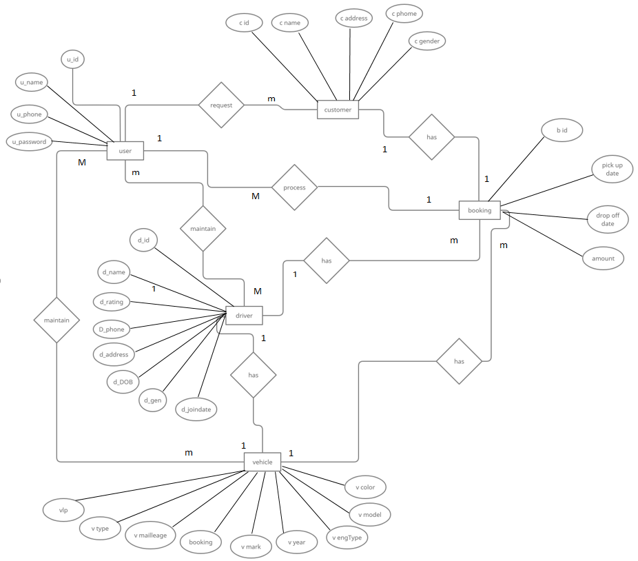

ER to relational mapping

**Relational mapping**

|  |  |  |  |
| --- | --- | --- | --- |
| U_id | U_name | U_phone | U_passwird |

User

vehicle

|  |  |  |  |  |  |  |  |  |  |
| --- | --- | --- | --- | --- | --- | --- | --- | --- | --- |
| Vlp | V mark | V model | V year | V eng type | V color | V maillege | booking | V type | U_id |

Driver

|  |  |  |  |  |  |  |  |  |
| --- | --- | --- | --- | --- | --- | --- | --- | --- |
| D_id | D_name | D_phone | D_add | D_dob | D_JoinDate | D_gen | D_rating | U_id |

|  |  |  |  |  |  |
| --- | --- | --- | --- | --- | --- |
| C_id | C_name | C_add | C_phone | C_gen | U_id |

Customer

|  |  |  |  |  |  |  |  |
| --- | --- | --- | --- | --- | --- | --- | --- |
| B_id | Pickupdate | Dropoffdate | Amount | V_lp | D_id | C_id | U_id |

Booking

1. **Normalization**
   1. **UN formation**

|  |  |  |  |
| --- | --- | --- | --- |
| U_id | U_name | U_phone | U_passwird |

User

vehicle

|  |  |  |  |  |  |  |  |  |
| --- | --- | --- | --- | --- | --- | --- | --- | --- |
| Vlp | V mark | V model | V year | V eng type | V color | booking | V maillege | V type |

Driver

|  |  |  |  |  |  |  |  |
| --- | --- | --- | --- | --- | --- | --- | --- |
| D_id | D_name | D_phone | D_add | D_dob | D_JoinDate | D_gen | D_rating |

|  |  |  |  |  |
| --- | --- | --- | --- | --- |
| C_id | C_name | C_add | C_phone | C_gen |

Customer

|  |  |  |  |
| --- | --- | --- | --- |
| B_id | Pickupdate | Dropoffdate | Amount |

booking

* 1. **1st normalization**

|  |  |  |
| --- | --- | --- |
| U_id | U_name | U_passwird |

User

User phone

|  |  |
| --- | --- |
| U_id | U_phone |

Vehicle

|  |  |  |  |  |  |  |  |  |
| --- | --- | --- | --- | --- | --- | --- | --- | --- |
| Vlp | V mark | V model | V year | V eng type | V maillege | V type | booking | U_id |

Vehicle color

|  |  |
| --- | --- |
| Vlp | Vcolor |

Driver

|  |  |  |  |  |  |  |  |
| --- | --- | --- | --- | --- | --- | --- | --- |
| D_id | D_name | D_add | D_dob | D_JoinDate | D_gen | D_rating | U_id |

Driver phone

|  |  |
| --- | --- |
| D_id | D_phone |

|  |  |  |  |  |
| --- | --- | --- | --- | --- |
| C_id | C_name | C_add | C_gen | U_id |

Customer

Customer phone

|  |  |
| --- | --- |
| C_id | C_phone |

|  |  |  |  |  |  |  |  |
| --- | --- | --- | --- | --- | --- | --- | --- |
| B_id | Pickupdate | Dropoffdate | Amount | V_lp | D_id | C_id | U_id |

Booking

* 1. **2nd normalization**

|  |  |  |
| --- | --- | --- |
| U_id | U_name | U_passwird |

User

User phone

|  |  |
| --- | --- |
| U_id | U_phone |

Vehicle

|  |  |  |  |  |  |  |  |  |
| --- | --- | --- | --- | --- | --- | --- | --- | --- |
| Vlp | V mark | V model | V year | V eng type | V maillege | V type | booking | U_id |

Vehicle color

|  |  |
| --- | --- |
| Vlp | Vcolor |

Driver

|  |  |  |  |  |  |  |  |
| --- | --- | --- | --- | --- | --- | --- | --- |
| D_id | D_name | D_add | D_dob | D_JoinDate | D_gen | D_rating | U_id |

Driver phone

|  |  |
| --- | --- |
| D_id | D_phone |

|  |  |  |  |  |
| --- | --- | --- | --- | --- |
| C_id | C_name | C_add | C_gen | U_id |

Customer

|  |  |
| --- | --- |
| C_id | C_phone |

Customer phone

Booking

|  |  |  |  |  |
| --- | --- | --- | --- | --- |
| B_id | Pickupdate | Dropoffdate | Amount | U_id |

Booking vehicle

|  |  |  |  |  |
| --- | --- | --- | --- | --- |
| B_id | Pickupdate | Dropoffdate | Amount | V_lp |

Booking driver

|  |  |  |  |  |
| --- | --- | --- | --- | --- |
| B_id | Pickupdate | Dropoffdate | Amount | D_id |

Booking customer

|  |  |  |  |  |
| --- | --- | --- | --- | --- |
| B_id | Pickupdate | Dropoffdate | Amount | C_id |

* 1. **3rd normalization**

|  |  |  |
| --- | --- | --- |
| U_id | U_name | U_passwird |

User

User phone

|  |  |
| --- | --- |
| U_id | U_phone |

Vehicle

|  |  |  |  |  |  |  |  |  |
| --- | --- | --- | --- | --- | --- | --- | --- | --- |
| Vlp | V mark | V model | V year | V eng type | V maillege | V type | booking | U_id |

Vehicle color

|  |  |
| --- | --- |
| Vlp | Vcolor |

|  |  |  |  |  |  |  |  |
| --- | --- | --- | --- | --- | --- | --- | --- |
| D_id | D_name | D_add | D_dob | D_JoinDate | D_gen | D_rating | U_id |

Driver

Driver phone

|  |  |
| --- | --- |
| D_id | D_phone |

|  |  |  |  |  |
| --- | --- | --- | --- | --- |
| C_id | C_name | C_add | C_gen | U_id |

Customer

Customer phone

|  |  |
| --- | --- |
| C_id | C_phone |

Booking

|  |  |  |  |  |
| --- | --- | --- | --- | --- |
| B_id | Pickupdate | Dropoffdate | Amount | U_id |

Booking vehicle

|  |  |  |  |  |
| --- | --- | --- | --- | --- |
| B_id | Pickupdate | Dropoffdate | Amount | V_lp |

Booking driver

|  |  |  |  |  |
| --- | --- | --- | --- | --- |
| B_id | Pickupdate | Dropoffdate | Amount | D_id |

Booking customer

|  |  |  |  |  |
| --- | --- | --- | --- | --- |
| B_id | Pickupdate | Dropoffdate | Amount | C_id |